Customer Change in Circumstances guide

Change in circumstances for existing applicants

If you are already registered and your application is active but you need to tell us about a change in circumstances, you need to log in to your online account and update your application form with the changes. This will ensure that your application is up to date and that you can bid for suitable properties which meet your needs and have been awarded the right level of priority.

Please ensure that you go to the last page of the form and press submit once you have made the relevant changes to your application.

The application will not be suspended whilst we are reassessing your application. We will email you to request any extra information or documentation required to support your changes and you must provide this within the stated timescale or your application will be cancelled.

Examples of changes of circumstances are detailed below, although this list is not exhaustive:

• You change your address
• Someone in your household has moved in or out your home
• You want to add or remove a family member to your application e.g. birth of a child
• Change of medical circumstances of any household member
• Death of a joint applicant or household member
• Any other circumstances that may materially affect your application

In order to make a change to your application you must first log into your account
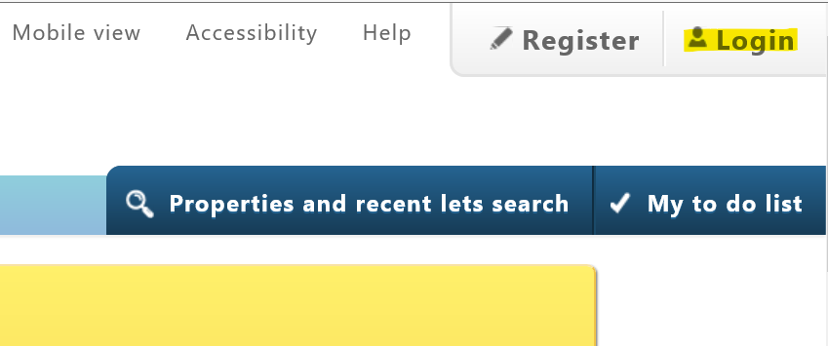

You will then see the dashboard displaying your application details. In order to make a change to your application, please select ‘Edit your online application form’
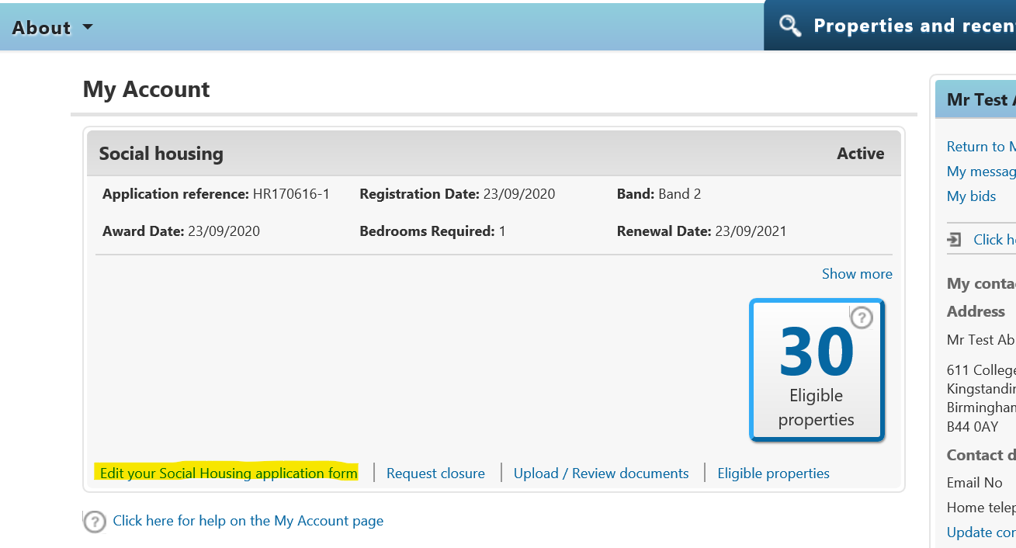

This will take you into the application, which will have the details you previously added to it.
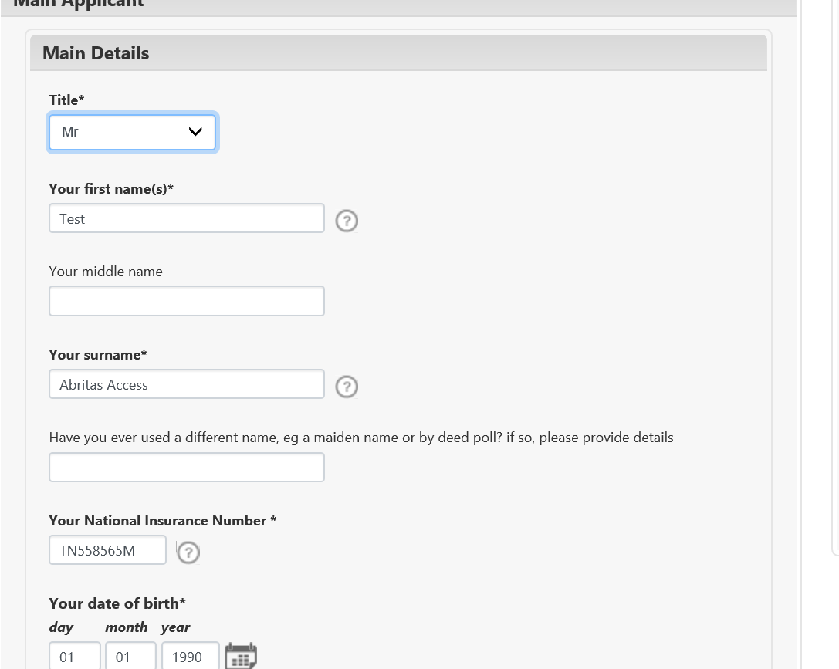

You can also add supporting documents to the application if they have been requested from you.
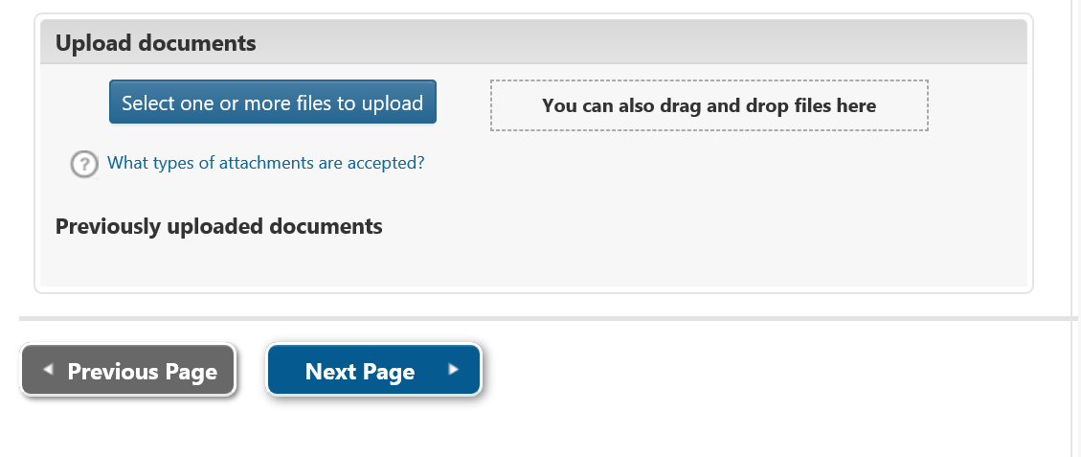

Simply progress through the application and amend the areas you want to update

When you have made the changes to the application and got to the and of the form, please select Submit form.
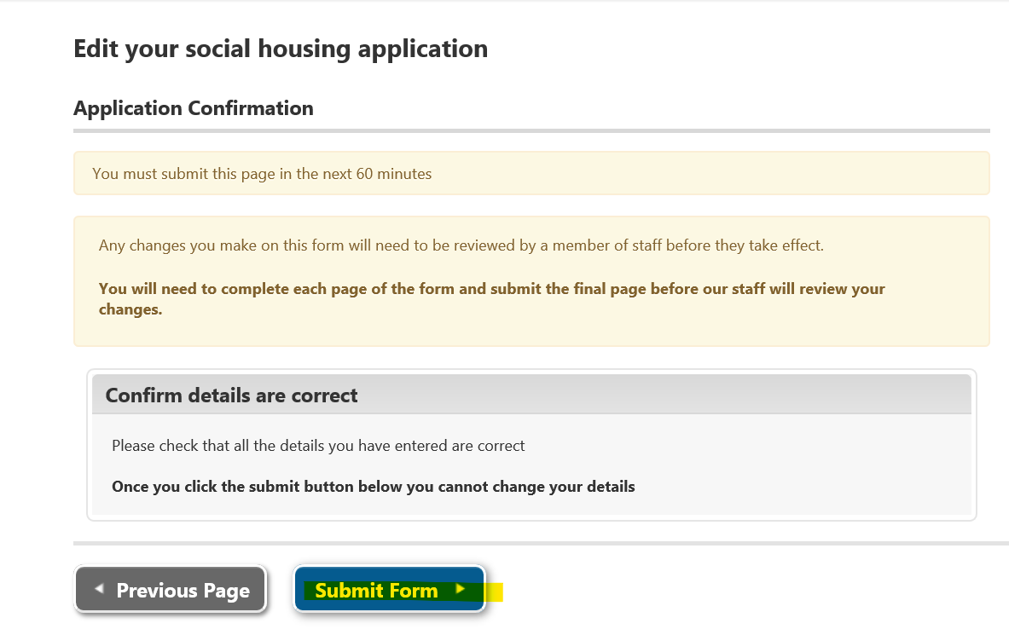

Once submitted, it will be sent to the Registration Team for assessment. Whilst it is awaiting assessment you will still be able to bid for property as normal.
